|  |
| --- |
|  |
| 新概念 3 册 |
| Lesson34 A happy discovery |

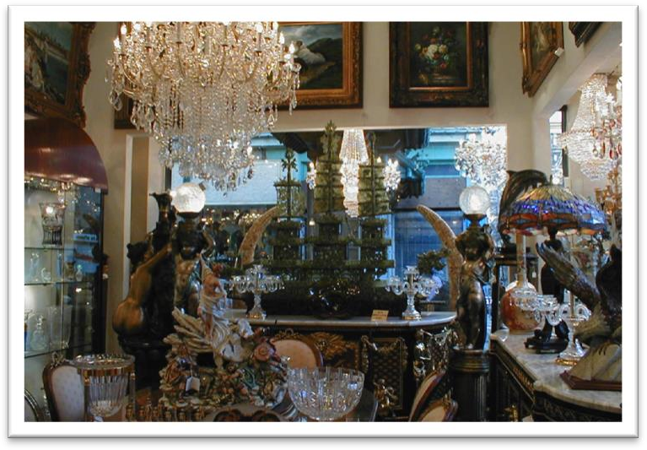

Book

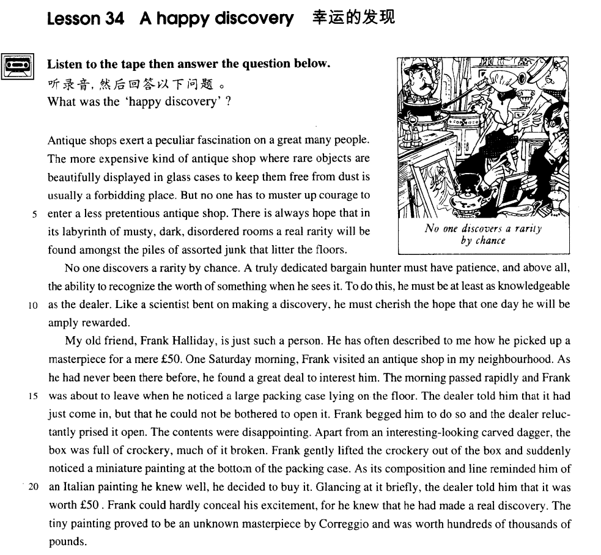

课文

Antique shops exert a peculiar fascination on a great many people.

古玩店对许多人来说有一种特殊的魅力。

The more expensive kind of antique shop where rare objects are beautifully displayed in glass cases to keep them free from dust is usually a forbidding place.

高档一点的古玩店为了防尘，把文物漂亮地陈列在玻璃柜子里，那里往往令人望而却步。

But no one has to muster up courage to enter a less pretentious antique shop.

而对不太装腔作势的古玩店，无论是谁都不用壮着胆子才敢往里进。

There is always hope that in its labyrinth of musty, dark, disordered rooms a real rarity will be found amongst the piles of assorted junk that litter the floors.

人们还常常有希望在发霉、阴暗、杂乱无章、迷宫般的店堂里，从杂乱地摆放在地面上的、一堆堆各式各样的破烂货里找到一件稀世珍品。

No one discovers a rarity by chance.

无论是谁都不会一下子就发现一件珍品。

A truly dedicated bargain hunter must have patience, and above all, the ability to recognize the worth of something when he sees it.

一个到处找便宜的人必须具有耐心，而且最重要的是看到珍品时要有鉴别珍品的能力。

To do this, he must be at least as knowledgeable as the dealer.

要做到这一点，他至少要像古董商一样懂行。

Like a scientist bent on making a discovery, he must cherish the hope that one day he will be amply rewarded.

他必须像一个专心致志进行探索的科学家那样抱有这样的希望，即终有一天，他的努力会取得丰硕的成果。

My old friend, Frank Halliday, is just such a person.

我的老朋友弗兰克.哈利戴正是这样一个人。

He has often described to me how he picked up a masterpiece for a mere ￡50.

他多次向我详细讲他如何只花50英镑便买到一位名家的杰作。

One Saturday morning, Frank visited an antique shop in my neighbourhood.

一个星期六的上午，弗兰克去了我家附近的一家古玩店。

As he had never been there before, he found a great deal to interest him.

由于他从未去过那儿，结果他发现许多有趣的东西。

The morning passed rapidly and Frank was about to leave when he noticed a large packing case lying on the floor.

上午很快过去了，弗兰克正准备离去，突然看见地板上放着一只体积很大的货箱。

The dealer told him that it had just come in, but that he could not be bothered to open it.

古董商告诉他那只货箱刚到不久，但他嫌麻烦不想把它打开。

Frank begged him to do so and the dealer reluctantly prised it open.

经弗兰克恳求，古董商才勉强把货箱撬开了。

The contents were disappointing.

箱内东西令人失望。

Apart from an interesting-looking carved dagger, the box was full of crockery, much of it broken.

除了一柄式样别致、雕有花纹的匕首外，货箱内装满陶器，而且大部分都已破碎裂。

Frank gently lifted the crockery out of the box and suddenly noticed a miniature painting at the bottom of the packing case.

弗兰克轻轻地把陶器拿出箱子，突然发现在箱底有一幅微型画，

As its composition and line reminded him of an Italian painting he knew well, he decided to buy it.

画面构图与纸条使他想起一幅他所熟悉的意大利画，于是他决定将画买了下来。

Glancing at it briefly the dealer told him that it was worth ￡50.

古董商漫不经心看了一眼那幅画，告诉弗兰克那画值50英镑。

Frank could hardly conceal his excitement, for he knew that he had made a real discovery.

弗兰克几乎无法掩饰自己兴奋的心情，因为他明白自己发现了一件珍品。

The tiny painting proved to be an unknown masterpiece by Correggio and was worth hundreds and thousands of pounds.

那幅不大的画原来是柯勒乔的一幅未被发现的杰作，价值几十万英镑。

词汇讲解

* **forbidding [fə'bɪdɪŋ]** adj. 令人望而生畏的；冷冰冰的
* a **forbidding** place
* a **forbidding** appearance

**【近义词汇】**

**unfriendly** ***adj.*** 不友好的；冷漠的；有敌意的

**unwelcoming** ***adj.*** （对造访者）不亲切的，不热情的，冷淡的

**inhospitable** ***adj.*** 不殷勤待客的；不好客的

**hospitable** ***adj.*** 好客的；热情友好的；殷勤的

* The Chinese are very **hospitable**.
* The Chinese are noted for their **hospitality**.

**【同根词】**

**forbidden** 禁止的；不准的

* the Forbidden City 紫禁城
* the forbidden fruit 禁果
* **muster ['mʌstə(r)]** v. 鼓起，激起，振作起

**muster (up) sth.**

= **summon (up) sth.**

* **muster / summon (up)** courage 鼓起勇气
* **muster / summon (up)** enthusiasm 激起热情
* **muster / summon (up)** strength 振作起力量
* **junk [dʒʌŋk] [U]** n. 废品，破烂货
* a piece of junk 一件废品
* The cupboard is full of **junk**.
* junk food / mail 垃圾食物/邮件

**clutter** **[U]**杂乱的东西（尤指不需要的或无用的）；杂乱

* Those who never have to move house become indiscriminate collectors of what can only be described as **clutter**.

【相关词汇】**“垃圾”**

**rubbish** **[U]** 垃圾；废弃物

**trash** **[U]** 废物；垃圾

**refuse** **[U]** 废弃物；垃圾

**garbage** **[U]** （生活）垃圾；废物

**litter** **[U]** （在公共场所乱扔的）垃圾，废弃物，杂物

**clutter**

* Magazines **littered / cluttered** the floor. (动词用法)

**be littered / cluttered with ...** 胡乱的堆满…

* The garden **was soon littered with** chunks of metal which had once made up a lawn mower.
* **dealer** ['di:lə(r)] n. 商人 （有专业知识商人、内行）
* an **antique** dealer 古董商人
* a **furniture** dealer 家具商人

【相关词汇】**“商人”**

**businessman** / **merchant** （大）商人

**vendor** 小贩；摊贩

**retailer** 零售商；零售店

**wholesaler** 批发商

**supplier** 供应者；供货商；供货方

**sales** **representative** 销售代表

**assistant** / **clerk** 售货员

**real estate agent**  房地产经纪人

**grocer** 杂货商

**stationer** 文具商

* **cherish** ['tʃerɪʃ] v. 珍爱，珍视；长期怀有某种感情
* I’ll **cherish** our friendship for ever.

【相关词汇】**“v. 珍视”**

**treasure** v. 珍视；珍爱；珍重；珍藏

**value** v. 重视；珍视

【相关词汇】**“adj. 珍视”**

* Mary’s **cherished** possessions
* Mary’s **prize** possessions

**treasured**

**valued**

**课文：**

**cherish** 表达 “长期怀有某种感情”时：

* He **cherished** the hope of winning an Olympic medal.
* He **cherished** the memory of his late wife.
* He **cherished** the illusion that the girl was in love with him.

课文讲解

# （标题）

# A happy discovery

**happy**: lucky; fortunate； 幸运的

* a happy coincidence 幸运的巧合
* the happy few 幸运的少数
* The **sad**（不幸的） truth is that most of us have been brought up to eat certain foods and we stick to them all our lives.
* He made a **sad**（不幸的） mistake.
* **老友记**
* I guess I set up the video camera to try and entice
* Joey. But **sadly**（不幸地） I could not be enticed.

# （第一段）

# Antique shops exert a peculiar fascination on a great many people.

1. lesson26

**exert ... on ...** 施加某种…

* Much as we may pride ourselves on our good taste, we are no longer free to choose the things we want, for advertising **exerts** a subtle influence **on** us.

**fascination** 魅力；魔力

* Cats never fail to fascinate human beings.

【近义词组】表达“**吸引力**”：

**charm**

**attraction**

**appeal**

* In spite of national differences, certain funny situations have a universal **appeal**.



**sth. exert a peculiar fascination on sb.** 某人特别着迷某事

* **造句**：很多中国年轻人非常喜欢韩国的 (Korean) 电视剧 (TV dramas)。
* Korean TV dramas exert a peculiar fascination on a great many Chinese young people.

# The more expensive kind of antique shop where rare objects are beautifully displayed in glass cases to keep them free from dust is usually a forbidding place.

**语法分析：**

The more expensive kind of antique shop where（定语从句） rare objects are beautifully displayed in glass cases *to keep them free from dust（目的状语）* is usually a forbidding place.

知识点（1） Lesson6

**expensive** 高档、豪华的

* The **expensive** shops in a famous arcade near Piccadilly were just opening.

知识点（2）

表达“**种类**”：

* a new kind **of** **machine**
* **machines** **of** a new kind

知识点（3） Lesson26

**(be) free from ...** 没有某个不希望有的东西

* He may never be sure where the next meal is coming from, but he **is free from** the thousands of anxieties which afflict other people.
* The composition **is free from** errors.
* Organic produce **is free from** harmful chemicals.

**free ... from ...** 使…没有

* He dedicated his life to **freeing** the world **from** famine and disease.

# But no one has to muster up courage to enter a less pretentious antique shop.

**pretentious** adj. 自命不凡的；装腔作势的

* **造句**: 谁也不用壮着胆子去接近一个不那么装腔作势的女孩子。
* No one has to muster up courage to approach a less pretentious girl.

# There is always hope that in its labyrinth of musty, dark, disordered rooms a real rarity will be found amongst the piles of assorted junk that litter the floors.

**语法分析：**

There is always hope **that（同位语从句）** in its labyrinth of musty, dark, disordered rooms（地点状语) a real rarity will be found *amongst the piles of assorted junk that litter the floors（定语从句，修饰junk）. （amongst…地点状语)*

知识点（1）

**there be + 无灵主语** （地道句式）

* **there is no denying that ...** 不可否认的是…
* **there is no doubt that ...** 毫无疑问的是…
* **there is every likelihood that ...** 很有可能的是…
* **there is little likelihood that ...** 不大可能的是…
* **there is no shortage of ...** 有的是…
* Of course, New York is the ideal place for such an interesting study, because **there is no shortage of** tall buildings.
* **there is an element of truth in ...** 有点道理
* Perhaps **there is an element of truth in** both these pictures, but few of us have had the opportunity to find out.
* **there is a good deal of truth in ...** 很有道理
* Apparently, **there is a good deal of truth in** this idea.

知识点（2）

**hope** [C, U] 希望、可能性

**… hope of**

**… hope that**

* **There is little hope of** any improvement in his condition.
* **There's still a faint hope that** the two sides will reach an agreement.
* It was rush hour, and **there was no hope of** getting a seat.
* **Is there any hope of** getting financial support for the project?
* **Is there any hope that** she will change her mind?

知识点（3）

**labyrinth** **of** musty, dark, disordered rooms 迷宫一样的…

**语法：比喻 （ 喻体 + of + 本体）**

* *a boy* of a girl
* *an angel* of a wife
* *a palace* of a house
* *a garden* of Switzerland
* Jane is *a submissive lamb* of a girl.

知识点（4）Lesson17

**amongst**: among

**whilst**: while

**midst**: middle

知识点（5）

**assorted** 各式各样的

* **assorted** vegetables
* a box of **assorted** chocolates
* tools in **assorted** sizes
* swimsuits in **assorted** colors

# （第二段）

# No one discovers a rarity by chance.

【近义词组】表达“**随便地、意外地、偶然地**”：做状语

**by chance**

**by accident**

**accidentally**

* No one succeeds **by chance**.

【近义词组】表达“**故意地、诚心地、有预谋地**”： 做状语

**intentionally**

**deliberately**

**on purpose**

# A truly dedicated bargain hunter must have patience, and above all, the ability to recognize the worth of something when he sees it.

**语法分析：**

A truly dedicated bargain hunter must have *patience（宾语）*, and above all (状语), *the ability to recognize the worth of something*（并列宾语）when he sees it（时间状语）.

知识点（1）

**above all (else)** 最重要的事

* Max is clever, hardworking, and **above all (else)** honest.
* **造句**：一个真正全身心投入的猎头必须要有耐心，并且最重要的是，要有识才的慧眼。
* A truly dedicated head-hunter must have patience, and **above all**, an eye for talents. He has an eye for beauty.

# To do this, he must be at least as knowledgeable as the dealer.

知识点（1）

knowledgeable 知识渊博的

知识点（2）

**as … as …** as(副词)…as(“像” 连词，**固定句型**后面省略谓语动词)…

**as** … （作为**连词**单独使用不能使用谓语动词）

* When at Rome, do **as** （“像”）the Romans do.
* When at Rome, do **like** the Romans.
* ... Alfred Bloggs who worked **as**（“是，作为”，介词） a dustman for the Ellesmere Corporation.

**介词：**

* She spoke **as**（“作为”，介词） a lawyer.
* She spoke **like**（“像”，介词） a lawyer.

**连词：**

* He must be **as** knowledgeable as the dealer (is).
* He isn’t **as / so** knowledgeable as the dealer (is).

# Like a scientist bent on making a discovery, he must cherish the hope that one day he will be amply rewarded.

**语法分析：**

*Like a scientist（介词短语做状语） bent on making a discover*y*（形容词短语做后置定语）*, he must cherish the hope that one day he will be amply rewarded（同位语从句）.

知识点（1）

**be bent on sth. / doing**一门心思做某事

* The boy **is bent on** mischief*.
* He **is bent o**n winning at all costs.

【近义词组】表达“下定决心做某事”：

**be determined to do**

**be resolved to do**

**set one’s mind on sth. / doing**

**课文写法替换：**

* Like a scientist **determined to make a discovery.**
* Like a scientist **resolved to make a discovery.**
* Like a scientist **setting his mind on making a discovery.**

知识点（2） Lesson3

【近义词组】表达“有（某种感情）”：

**cherish**

**nourish**

* Lisa has long **nourished** the hope of becoming a ballerina.
* The city at one time must have been prosperous, for it **enjoyed**（“享有”） a high level of civilization.
* There is a lot of beautiful scenery in China.
* China **boasts**（“有”） a lot of beautiful scenery.
* They have three lovely children.
* They are **blessed** with three lovely children.
* The girl has both beauty and brains.
* The girl **is endowed with**（“（先天就）有”） both beauty and brains.

知识点（3）

**be rewarded** 获得回报

**be amply rewarded** 获得丰厚回报

* There is always hope that all my patience will **be amply rewarded**.

# （第三段）

# My old friend, Frank Halliday, is just such a person.

# He has often described to me how he picked up a masterpiece for a mere ￡50.

**语法分析：**

He has often described *to me（状语，前置）* how he picked up a masterpiece for a mere £50. （宾语从句，长句后置）

知识点（1）

**describe … to sb.** 把某事描述给某人

* Let me **describe *to you***how it happened.

**状语前置句式:**

* Wherever it went, it left ***behind it*** a trail of dead deer and small animals like rabbits. （句式）
* On the occasions when they have pushed ***to shore***an unconscious human being …

**describe … as …** 把…描述成…

* He **described it as** 'a very agreeable situation located within two small hills in the midst of which flowed a great river.'
* Those who never have to move house become indiscriminate collectors of what can only **be described as** clutter.

知识点（2）

**pick sth. ↔ up**（up副词，位置灵活）幸运的买到便宜货

* We managed to **pick up** a few bargains at the auction.

知识点（3）

**a mere …** 仅仅…… （强调很小）

* He's **a mere** child.
* It took her **a mere** 20 minutes to win.
* Glancing at his map, he informed us that the next village was **a mere** twenty miles away.

# One Saturday morning, Frank visited an antique shop in my neighbourhood.

知识点（1）

neighbourhood 临近地区

【近义词组】表达“**在…附近**”：

a famous arcade **near** Piccadilly

a famous arcade **close to** Piccadilly

a famous arcade **around** Piccadilly

a famous arcade **off** Piccadilly

a famous arcade **in the neighbourhood / vicinity of** Piccadilly

表达“**近**”：

**only a short bus ride away** 坐公交车一会儿就到了

* The latest exhibitions, films, or plays are **only a short bus ride away**.

**within walking distance** 走着走着就到了

**within driving distance** 开车就到了

**within commuting distance** 坐车交到了

**only a stone’s throw away** 仅仅一段举例

# As he had never been there before, he found a great deal to interest him.

**课文写法替换：**

* **Having** never been there before, ... 非谓语
* **As** this was his first visit there, ... 原因状语从句
* **(with)** This **being** his first visit there, ... 独立主格

**课后题：**

7．___A___ there, he found a great deal to interest him. (11.13-14)

(a) This being his first visit

(b) Never having been before （there不能在before之后，never不放在助动词之后）

(c) This being his first time to visit (visit 变成动词了)

(d) Having never been before （there不能在before之后，never不放在助动词之后）

# The morning passed rapidly and Frank was about to leave when he noticed a large packing case lying on the floor.

# The dealer told him that it had just come in, but that he could not be bothered to open it.

**语法分析：**

The dealer told him that it had just come in （宾语从句）, but that（不能省略，避免歧义） he could not be bothered to open it. （宾语从句

知识点（1）

**语法：**并列宾语从句，第一个that可省略，第二个不能省略

* Galileo’s observations show **(that)** Copernicus, another great astronomer, was right and **that** the earth moves around the sun, not the other way around.
* He agreed **that** a train did come into the station at the time on the paper and **that** it did stop, but only to take on mail, not passengers.

知识点（2）

**can't be bothered (to do sth)** 嫌麻烦（而不愿……）

* The grass needs cutting but I **can't be bothered to do it** today.
* He could produce excellent work but usually he **can't be bothered**.

# Frank begged him to do so and the dealer reluctantly prised it open.

知识点（1）

reluctantly 不情愿的

* When the journalist again failed to reply, the editor **reluctantly** published the article as it had originally been written.

【近义词组】表达“不情愿的”：

**unwillingly**

**with reluctance**

知识点（2）

**prise / pry sth. open** 撬开

# The contents were disappointing.

# Apart from an interesting-looking carved dagger, the box was full of crockery, much of it broken.

**语法分析：**

*Apart from（介词短语做状语）* an interesting-looking carved dagger, the box was full of crockery, much of it broken（独立主格）.

知识点（1）

**apart from ... / aside from ...**

**1.表示“除了…之外”**

【近义词组】

**except ... / except for ...**

**but / but for ...**

**excluding ...**

**other than ...**

**with the exception of ...**

* **Apart / Aside from** the ending, it's a really good film.
* I hardly know anyone in town **apart / aside from** William and you.

**2.表示“除了…，还有…”**

【近义词组】

**besides**

**as well as ...**

**in addition to ...**

* **Apart / Aside from** the injuries to his face and hands, he broke both legs.
* **Apart / Aside from** these two books, he has written some plays and film scripts.

知识点（2）

**课文写法替换：**

* ... the box was full of crockery, and much of it was broken.（没有独立主格简洁，不突出重点）
* ... the box was full of crockery, much of which was broken. （没有独立主格简洁）
* **造句**：这个箱子 (chest) 里除了一些金条 (gold bullion) 之外, 装满了宝石 (precious stone)，其中大多数都是钻石。
* Apart from some gold bullion, the chest was full of precious stones, most of them diamonds.

# Frank gently lifted the crockery out of the box and suddenly noticed a miniature painting at the bottom of the packing case.

# As its composition and line reminded him of an Italian painting he knew well, he decided to buy it.

**语法分析：**

As its composition and line reminded him of an Italian painting *he knew well（定语从句）* （原因状语从句), he decided to buy it.

知识点（1）

**remind sb. of sth.** 使某人回忆起某事

* That song always reminds me of our first date.

**remind sb. about sth.** 提醒某人某事

**remind sb. to do sth.** 提醒某人**做**某事

* Can you **remind us about your plans** for the building?
* **Remind me to buy** some milk tonight.

知识点（2）

**课文写法替换：**

Its composition and line *reminding him of an Italian painting he knew well*（独立主格）, he decided to buy it.

# Glancing at it briefly the dealer told him that it was worth ￡50.

**语法分析：**

Glancing at it briefly（非谓语动词引导状语), the dealer told him *that it was worth £50（宾语从句）*.

知识点（1）

**glance at** 匆匆的看

* **Glancing at** his map, he informed us that the next village was a mere twenty miles away.

# Frank could hardly conceal his excitement, for he knew that he had made a real discovery.

**conceal** 掩饰、隐藏

* I had no intention of buying one, but I could not **conceal** the fact that I was impressed by the size of the diamonds.

**conceal**

反义：**reveal** 暴露，揭示

**课文写法替换：**

* Frank almost **revealed** his excitement.

**考研英语，英译汉：**

His function is analogous to that of a judge, who must accept the obligation of **revealing** in as obvious a manner as possible the course of reasoning which led him to his decision.

# The tiny painting proved to be an unknown masterpiece by Correggio and was worth hundreds and thousands of pounds.